Press release:

**Drought may not get worse over time in California**

Data analysis performed on long-term national climate data

May, 27th, 2018

Recently in the class “Do you think you can do statistics?”, the statistic group students of the University of Washington examine drought and precipitation datasets from National climate. By doing time series analysis and permutation test, they make a new discovery that drought condition may not get worse in California. Although many articles describe the drought situation in California is so severe that even times of substantial precipitation does not change the drought forecasts, it seems to be too definite.

Students looked at yearly data from 1895 to 2017 on drought palmer index in California as well as Washington state as a comparison. They found the trend of drought is slightly getting worse over time but with a relatively big variance. To have a better understanding of data, students applied time series analysis on yearly palmer index data in California. The analysis shows that drought severity in California is said to be stationary, implying that mean, variance, and covariance of annual Palmer index is time invariant. By fitting ARIMA models, the Palmer index is forecasted to fluctuate around mean value of 0, under the confidence interval of -4 to 4, in next ten years. Even though time series analysis comes out that drought in California is time irrelevant, students found that 15% area experienced exceptional drought and 30% lands were under extreme drought during the past seven years.

They also examined the monthly precipitation data from 1895 to 2017 for both California and Washington. The monthly precipitation level is stationary by ADF test. “Though the precipitation does not have a big shift in average from 1895 to 2017, there are some insights that precipitation in both California and Washington has increased in extreme events, for which further study may be needed,” said Chenxi Di, one of the project group member. The permutation test on drought comes out that dry patterns in CA and WA are not different, while the test on precipitation turns out that rainfall in these two states is different.

If you would like to know more information about this topic, welcome to email statistic groups’ mentor Peter Guttorp, guttorp@uw.edu.

Facebook post #1: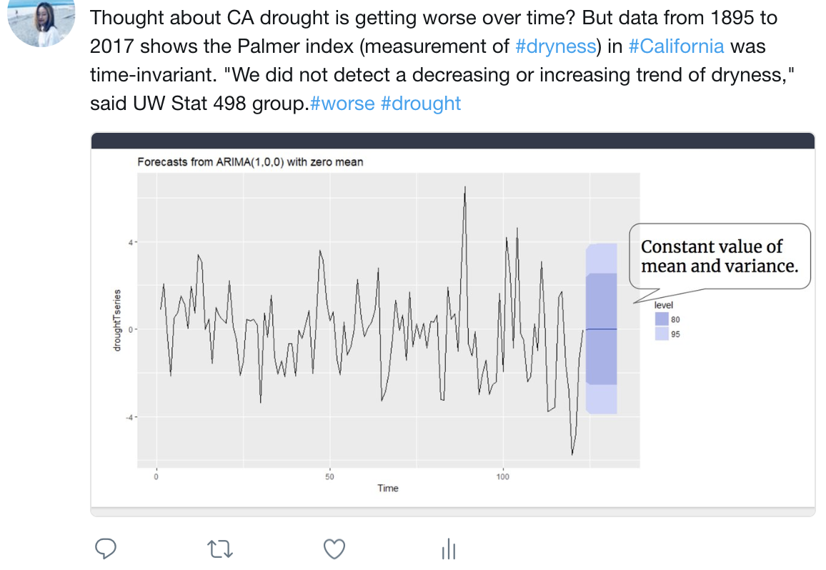

Facebook post #2:

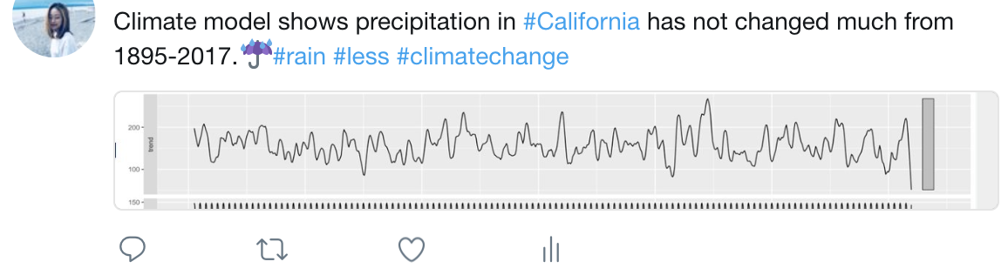

Facebook post #3:

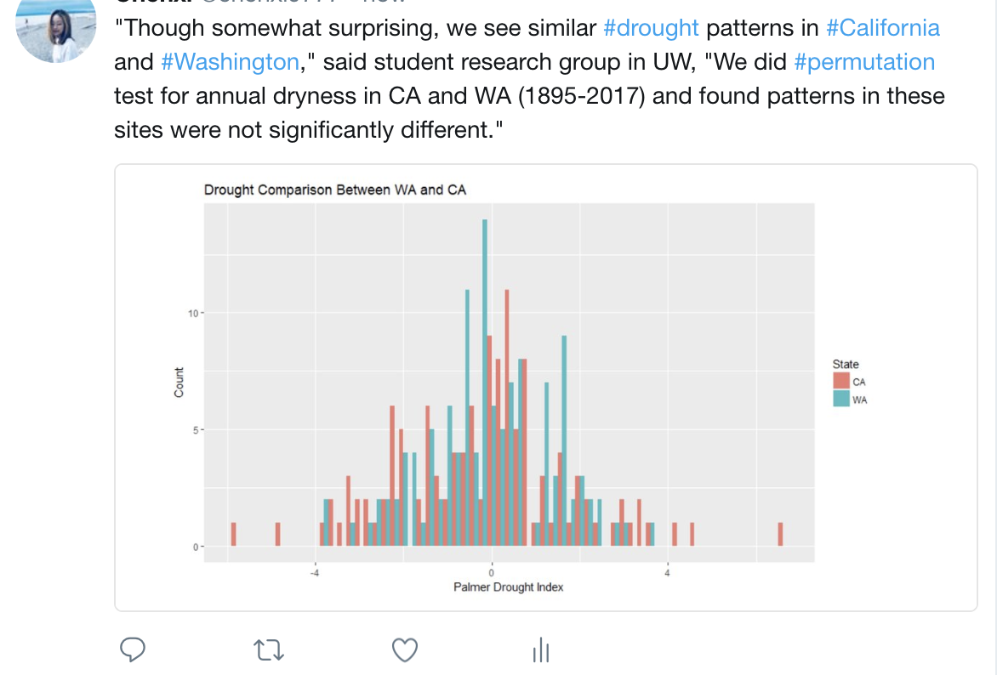

Facebook post #4:

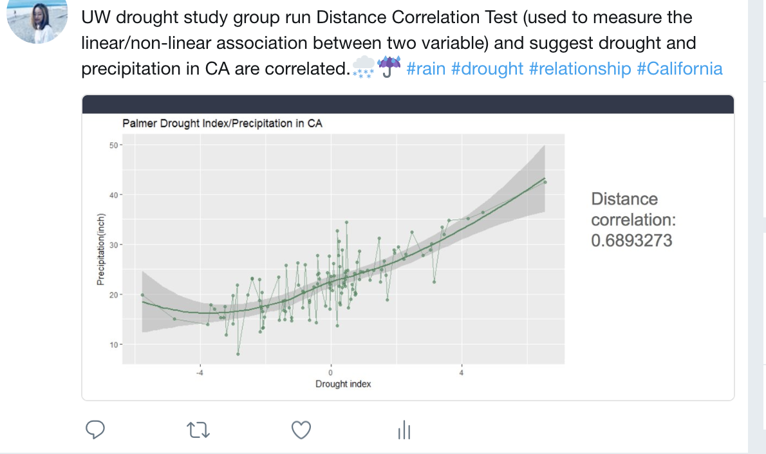

Facebook post #5:

